

92600527015Faculty of Computer Applications
BCA Sem-1
(AY-2026-27)

Lab Book

Sub Code : 05BC3103
(Programming Practices : 1)

Roll No : | 92600527023
Full Name : | Devam Narodiya

GitHub link https://github.com/devamnarodiya26/BCA-1-PP-1--92600527023-Devam-Narodiya

Sub.Faculty Name : Dr.Ashwin Dobariya
Index
Unit : 1
Program No | Definition
1. | Print "Hello World".
2. | 2 Values from user and Perform All Arithmetic Operations.
3. | Print numbers from 1 to 20.
4. | Input 3 values from user and find out its Average.
5. | Calculate the Square and Cube of a number.
6. | Interchange the value of two numbers.
7. | Find largest out of three numbers.
8. | Find out Fibonacci series up to given n values.
9. | Find out Number is Odd or Even.
10. | Find out sum of digits of a given number.
(1) Print "Hello World".

Algorithm :

Step 1 : START
Step 2 : PRINT “Hello World”
Step 3 : STOP

Flowchart :

PRINT “Hello World”
STOP
START

Code :

#include<stdio.h>
#include<conio.h>

void main(){
clrscr();
printf("Hello World");
getch();
}

Output :

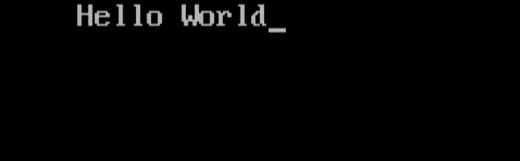

(2) 2 Values from user and Perform All Arithmetic Operations.
Algorithm :

Step 1 : START
Step 2 : DECLARE variables x=0.0, y=0.0, a, s, m, d
Step 3 : INPUT x,y
Step 4 : a = x + y
Step 5 : s = x – y
Step 6 : m = x * y
Step 7 : d = x / y
Step 8 : OUTPUT a, s, m, d
Step 9 : STOP

Flowchart :
START

DECLARE variables x=0.0, y=0.0, a, s, m, d

INPUT x, y

a = x + y

s = x - y

m = x * y

d = x / y

OUTPUT a, s, m, d

STOP

Code :

#include<stdio.h>
#include<conio.h>

void main()
{
float x,y;
clrscr();
printf("\n Enter Number 1: ");
scanf("%f",&x);
printf("\n Enter Number 2: ");
scanf("%f",&y);

printf(“Addition Is: %.2f \n”,x+y);
printf(“Subtraction Is: %.2f \n”,x-y);
printf(“Multiplication Is: %.2f \n”,x*y);
printf(“Division Is: %.2f \n”,x/y);

getch();

}

Output :
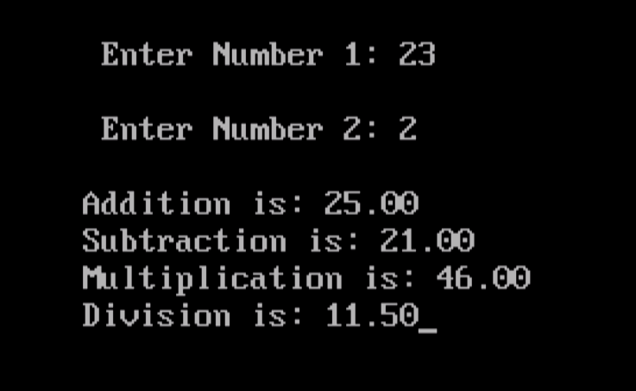

(4) Input 3 values from user and find out its Average.

Algorithm :

Step 1 : START
Step 2 : DECLARE variables x, y, z, avg
Step 3 : INPUT x, y, z
Step 4 : avg = (x + y + z) / 3
Step 5 : PRINT avg
Step 6 : STOP

Flowchart :

START

DECLARE variables x, y, z, avg

INPUT x, y, z

avg = (x + y + z) / 3

PRINT avg

STOP

Code :

#include<stdio.h>
#include<conio.h>

void main()
{
int x,y,z;
clrscr();
printf("\n Enter Number 1: ");
scanf("%d",&x);
printf("\n Enter Number 2: ");
scanf("%d",&y);
printf("\n Enter Number 3: ");
scanf("%d",&z);
printf("\n Average is: %d ",(x+y+z)/3);
getch();

}

Output :
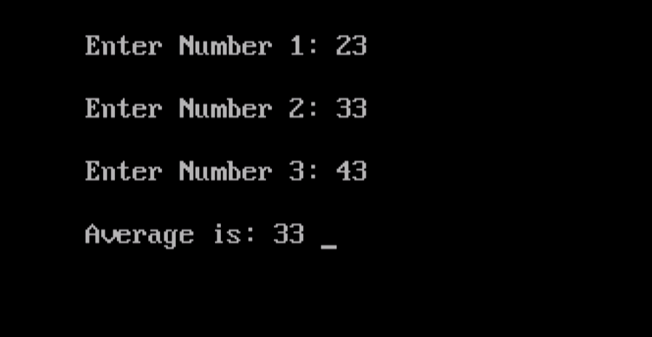

(5) Calculate the Square and Cube of a number.

Algorithm :

Step 1 : START
Step 2 : DECLARE variables n, sqr, cube
Step 3 : INPUT n
Step 4 : sqr = n * n
Step 5 : cube = n* n* n
Step 6 : OUTPUT sqr, cube
Step 7 : STOP

Flowchart :

STOP
DECLARE variables n, sqr, cube
START

INPUT n

sqr = n * n

cube = n * n * n

PRINT sqr, cube

Code :

#include<stdio.h>
#include<conio.h>

void main()
{
int n;
clrscr();
printf("\n Enter Number: ");
scanf("%d",&n);
printf("\n Enter Square: %d",n*n);
printf("\n Cube is: %d",n*n*n);
getch();

}
Output :

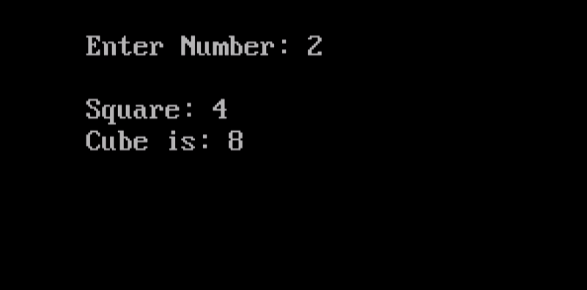

(6) Interchange the value of two numbers.

Algorithm :

Step 1 : START
Step 2 : DECLARE variables temp, x, y
Step 3 : INPUT x, y
Step 4 : temp = x
Step 5 : x = y
Step 6 : y = temp
Step 7 : PRINT x, y
Step 8 : STOP

Flowchart :
STOP
START

DECLARE variables temp, x, y

INPUT x, y

temp = x

x = y

y = temp

PRINT x, y

Code :

#include<stdio.h>
#include<conio.h>

void main()
{
int temp,x,y;
clrscr();
printf("\n Enter Number 1: ");
scanf("%d",&x);
printf("\n Enter Number 2: ");
scanf("%d",&y);
temp=x;
x=y;
y=temp;
printf("\nNew Number 1: %d",x);
printf("\nNew Number 2: %d",y);
getch();

}
Output :

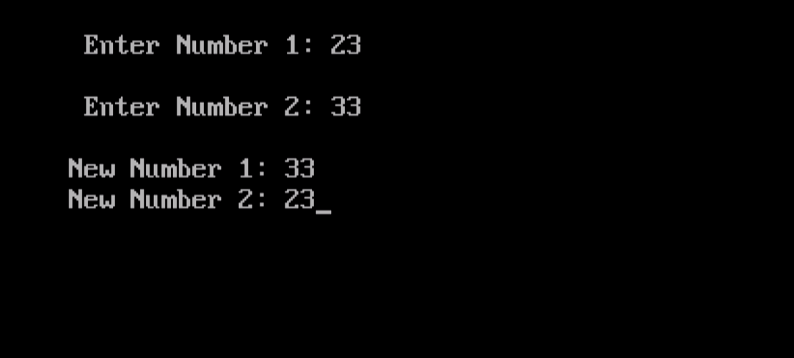

(7) Find largest out of three numbers.

Algorithm :

Step 1 : START
Step 2 : DECLARE variables X, Y, Z
Step 3 : INPUT X, Y, Z
Step 4 : IF X>Y&&X>Z THEN
PRINT “X is Largest”
Step 5 : ELSE IF Y>Z&&Y>X THEN
PRINT “Y is Largest”
Step 6 : ELSE
PRINT “Z is Largest”
Step 7 : STOP

Flowchart :
START

DECLARE variables X, Y, Z

INPUT X, Y, Z

Is
X>Y&&X>Z ?
NO
YES

Is
Y>X&&Y>Z ?
NO
YES

PRINT “X IS LARGEST”

PRINT “Y IS LARGEST”
PRINT “Z IS LARGEST”

STOP
Code :

#include<stdio.h>
#include<conio.h>

void main(){
int x,y,z;
clrscr();
printf("\n Enter Number 1: ");
scanf("%d",&x);
printf("\n Enter Number 2: ");
scanf("%d",&y);
printf("\n Enter Number 3: ");
scanf("%d",&z);

if(x>y&&x>z){
printf("Number 1 is largest");
}
else if(y>z&&y>x){
printf("Number 2 is largest");
}
else{
printf("Number 3 is largest");
}
getch();

}
Output :
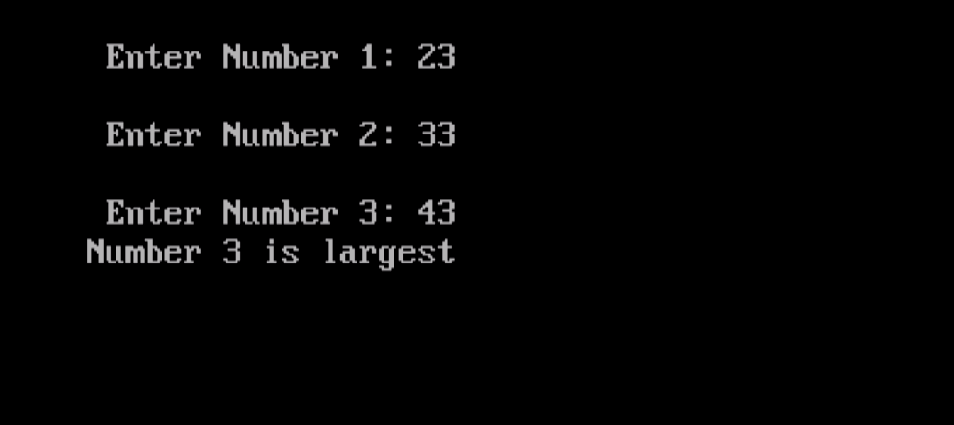

(9) Find out Number is Odd or Even.

Algorithm :

Step 1 : START
Step 2 : DECLARE variable x = 0
Step 3 : INPUT x
Step 4 : IF x % 2 = 0 THEN
PRINT “Even Number”
Step 5 : ELSE
PRINT “Odd Number”
Step 6 : STOP

Flowchart :

INPUT x
DECLARE variable x = 0
START

Is
x%2=0
?
NO
YES

PRINT “Odd Number”

PRINT “Even Number”

STOP
Code :

#include<stdio.h>
#include<conio.h>

void main()
{
int n;
clrscr();
printf("\n Enter Number: ");
scanf("%d",&n);

if(n%2==0){
printf("Even Number");
}
else
printf("Odd Number");
getch();
}
Output :
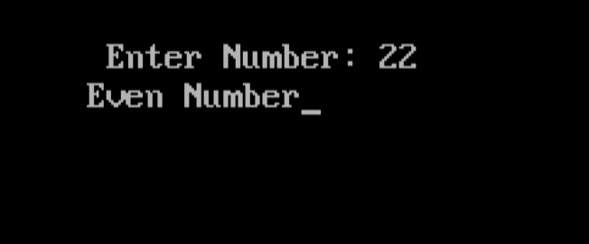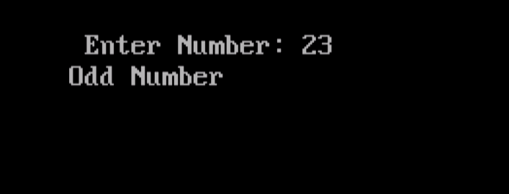

(10) Find out sum of digits of a given number.

Algorithm :

Step 1 : START
Step 2 : DECLARE variables n, x, y
Step 3 : INPUT n
Step 4 : x = n % 10
Step 5 : y = n / 10
Step 6 : OUTPUT x + y
Step 7 : STOP

Flowchart :
STOP
START

OUTPUT x + y
INPUT n
DECLARE variables n, x, y

x = n % 10

y = n / 10

Code :

#include<stdio.h>
#include<conio.h>

void main()
{
int n,x,y;
clrscr();
printf("\n Enter Two Digit Number: ");
scanf("%d",&n);
x=n%10;
y=n/10;
printf("Sum Of Digits is: %d",x+y);
getch();

}
Output :

